# From Data to Decisions: Unlocking Sales and Profit Insights

#### **Introduction**

This project focuses on analyzing sales data to gain insights into business performance. The analysis covers key metrics, including customer trends, order patterns, and financial performance, providing actionable insights to drive informed decision-making and improve overall profitability.

#### **Tools Used**

* **Tableau**: Used for visualizing and analyzing sales data, enabling the creation of interactive dashboards that provided key insights into profitability, sales trends, and customer behavior.
* **SQL**: Utilized for extracting, cleaning, and preparing data from relational databases, ensuring seamless integration into analysis workflows.
* **Google Colab**: Leveraged for coding and analysis in a cloud environment, enabling efficient data manipulation and visualization using Python.

#### **Data Collection and Cleaning**

**Data Collection**The sales data(US_Regional_Sales_Data) was sourced from data_world. Key variables included:

* **Customer ID**: Unique identifier for each customer.
* **Order Date**: Date of each transaction.
* **Product ID/Category**: Information on the product sold.
* **Order Quantity and Price**: Quantity sold and price per unit for each order.
* **Profit Contribution and Profit Margins**: Financial metrics associated with each transaction.

**Data Cleaning**To ensure data reliability, the following steps were performed:

1. **Handling Missing Values**: Removed or filled missing values in critical fields like **Order Date** and **Revenue**.
2. **Data Type Conversion**: Standardized fields such as **Order Date** to date format and numerical data for easier calculations.
3. **Removing Duplicates**: Eliminated duplicate entries to prevent skewed insights.
4. **Outlier Detection**:Identified and reviewed outliers in fields like Total Sales and Total Profit to maintain accurate trend insights.
5. **Standardization**: Ensured consistency across categorical fields, such as product categories.

### Methodology

### The project followed a structured approach to analyze sales and profitability trends.

### **Data Cleaning:** Handled missing values, removed duplicates, and standardized data types for accurate analysis.

### **Exploratory Data Analysis (EDA):** Identified key trends and patterns using Tableau dashboards and Python visualizations.

### **Profitability Analysis:** Assessed product-level sales and profitability to uncover high-performing categories.

### **Regional Analysis:** Compared regional sales performance to identify growth opportunities and optimize sales strategies.

### **Actionable Recommendations:** Delivered insights for stakeholders on improving product focus, regional campaigns, and seasonal marketing efforts.

### **Dashboards Documentation**

**1. Profitability Dashboard**

* **Overall Profit**: Total profit is $21,325,327.
* **Profit by Product**: Accessories, Photo Frames, and Bathroom Furniture are the most profitable. Cocktail Glasses, Table Linens, and Stemware have comparatively lower profitability yet in the top 10 .
* **Profit by Region**: Midwest and Northeast are the most profitable regions; South and West lag behind.
* **Profit Trend**: Profit peaked in 2019 but declined in 2020.
* **Profit Margin**: Stable across regions, with Midwest having the highest margin.

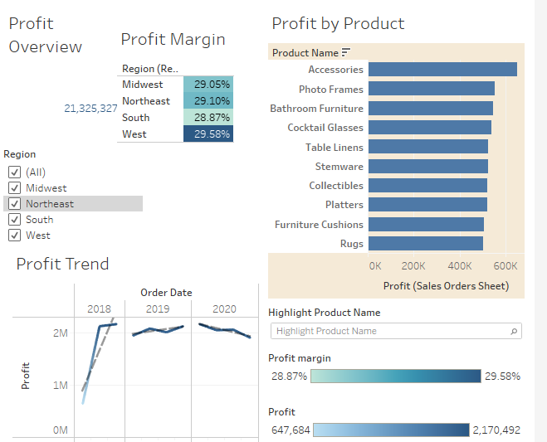

**2. Sales Dashboard**

* **Overall Sales**: Total sales are $73,143,380.
* **Sales by Region**: Midwest leads in sales, followed by Northeast. South and West have lower sales.
* **Best-Selling Products**: Accessories, Collectibles, and Photo Frames are top performers. Furniture Cushions and Platters underperform.
* **Sales Trend**: Sales peaked in 2019 but declined in 2020.

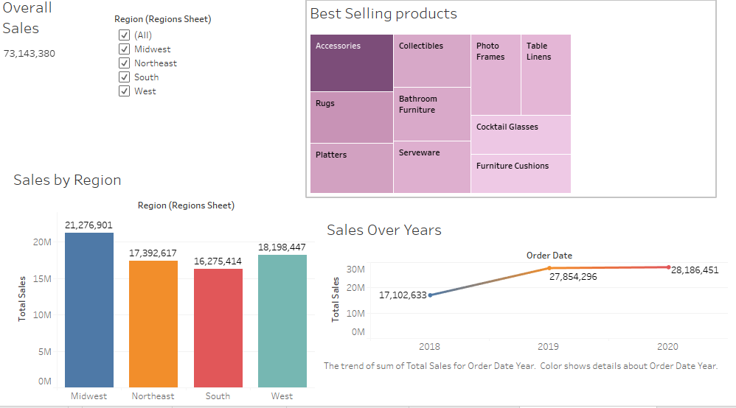

**3. Profit vs Sales Correlation Dashboard**

* **Profit vs Sales Trend**: Strong correlation between sales and profit, with both peaking in 2019 and declining in 2020.
* **Regional Correlation**: Midwest and Northeast show high sales and profit alignment; South and West lag behind.
* **Quarterly Performance**: Q2 and Q3 consistently outperform Q1 and Q4.
* **Profit Margin by Region**: West has the highest margin (29.58%), followed by Northeast (29.10%).

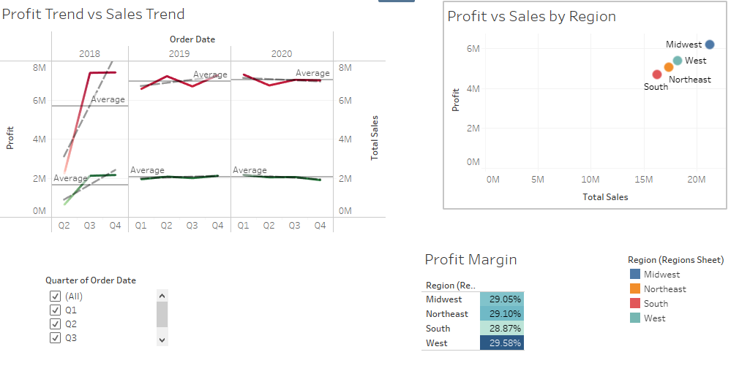

#### **Combined Insights**

1. **Regional Performance**: Midwest and Northeast lead in sales and profitability; South and West need improvement.
2. **Product Performance**: Accessories and Photo Frames are top performers; Furniture Cushions and Platters need strategic reviews.
3. **Trends Over Time**: 2019 was a peak year, but 2020 saw a decline, indicating potential external challenges.
4. **Seasonal Trends**: Q2 and Q3 are strong quarters; Q1 and Q4 require targeted campaigns.
5. **Profit Margin Stability**: Stable margins across regions, with West having the highest margin.

#### 

#### 

#### **Unveiling Sales and Profitability Insights for Strategic Growth**

**1. Actionable Recommendations for Stakeholders**

* **Regional Focus**: Invest in Midwest and Northeast; develop strategies for South and West.
* **Product Strategy**: Increase marketing for top-selling products; review underperformers.
* **Seasonal Adjustments**: Launch promotions in Q1 and Q4 to boost performance.
* **Profit Margins**: Maintain cost management practices; explore optimization opportunities.

**2. Profit vs Sales Correlation**

* **Key Takeaway**: Sales growth directly drives profitability. Focus on increasing sales in underperforming regions and quarters to boost overall profit.

#### **Conclusion**

This project provided a comprehensive analysis of sales performance, customer behavior, and profitability, identifying opportunities for enhancing business outcomes. By leveraging insights from customer segmentation, retention analysis, and profitability metrics, actionable strategies were outlined to boost customer retention, optimize product offerings, and increase revenue.

The recommendations, including loyalty programs, targeted marketing, and inventory optimization, offer practical steps to improve sales and long-term profitability. Implementing these strategies can help the business build stronger customer relationships, capitalize on peak sales periods, and maintain sustainable growth.

This analysis serves as a foundation for data-driven decision-making. Future analyses can expand on these findings by incorporating additional data sources or advanced modeling techniques to refine insights and further support strategic business initiatives.